Moments of Diversity, Equity & Inclusion Throughout the Year
Presented by AHP’s Equity Council
April 2025
Arab American Heritage, Autism Acceptance, Celebrate Diversity & National Deaf History Month
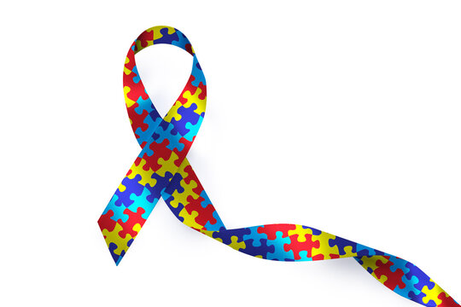
Important Dates
April 1 – Start of Month’s Themes
April 2 – World Autism Awareness Day
April 5 – Gold Star Spouses Day
April 7 – World Health Day
April 9 – International Day of Pink
April 22 – Earth Day
April 24 – Armenian Genocide Remembrance Day

Spiritual & Religious Celebrations
April 10: Jain: Mahavir Jayanti (Jainism)
April 12: The Memorial of Jesus’ Death (Jehovah Witness)
April 13-20: Passover (Jewish)
April 18: Good Friday (Christian)
April 14: Vaisakhi (Sikh, Hindu)
April 20: Easter (Christian)

Health Highlight
Autism (ASD)
WHO: 1 in 36 children in the United States are diagnosed with Autism. Boys are 4 times more likely than girls to be given an Autism diagnosis at a 4:1 ratio out of 100 children. Autism is less prevalent in white children than other racial and ethnic groups. In addition, 1 in 45 adults carry an Autism diagnosis. While diagnosis is most common in childhood, it is worth noting that symptoms are sometimes missed leading to a later in life diagnosis and therefore missed opportunities for lifelong supports.
WHAT: Autism “refers to a broad range of conditions characterized by challenges with social skills, repetitive behaviors, speech and nonverbal communication… Autism looks different for everyone, and each person with autism has a distinct set of strengths and challenges”
WHY: There is not one cause that leads to an Autism diagnosis, but there are many factors that increase risk. Evidence shows that children with a sibling who have ASD, genetic conditions, birth complications and maternal age all increase risk.
Reflection Video Resource

What is Autism?

References & Resources
https://www.cdc.gov/autism/about/index.html
https://www.apa.org/ https://www.clinicaladvisor.com/ https://www.edi.nih.gov/more/calendar/ https://www.diversityresources.com/may-diversity-calendar-2023
https://www.autismspeaks.org/autism-statistics-asd

Local Events & Celebrations
- 4/9 Honoring the Past, Inspiring the Future at the Amazon HQ Theatre @ 5:30pm
- 4/16 55th Earth Day Celebration at Winton Branch Library @ 11am
- 4/19 Community Clean Ups at Durand Eastman Beach Lot A @ 9am
- 4/26 Autism Acceptance & Awareness Walk at East View Mall @ 8am
Celebrate: Celebrate Diversity | National Deaf History | Gold Star Spouses | World Health Day | International Day of Pink | Armenian Genocide Commemoration

